Name :Aniket Rajaram Sawant
C-CAT NO : 260606350

Question 1:
#include <iostream>
#include <vector>
#include <string>
using namespace std;

class Student{
private:
int rollNumber;
string name;
double percentage;
static int totalStudents;

public:
Student(int r,string n)
{
rollNumber = r;
name = n;
percentage=0;
totalStudents;

cout<<"[Student Created] Roll:"<<r<<",Name:"<<n<<endl;
}

Student(const Student &s)
{
rollNumber = s.rollNumber;
name = s.name;
percentage = s.percentage;
totalStudents++;
cout <<"[Copy Constructor Called]"<<endl;
}

~Student(){
totalStudents--;
cout<<"[Student Deletedt] Roll:"<<rollNumber<<endl;

}

void setPercentage(double p)
{
if(p>=0 && p<=100)
{
percentage=p;
}
}

double getPercentage()const{
return percentage;
}

char calculateGrade()const{
if(percentage>=80)
return 'A';
else if(percentage>=70)
return 'B';
else if(percentage>=60)
return 'C';
else if(percentage>=50)
return 'D';
else
return 'F';
}

bool operator==(const Student &s)
{
return rollNumber == s.rollNumber;
}

friend ostream& operator<<(ostream &out,const Student &s)
{
out<<"Roll"<<s.rollNumber<<"| Name : "<<s.name<<" |Perecentage : "<<s.percentage<<"% |Grade : "<<s.calculateGrade();

return out;
}

static int getTotalStudents()
{
return totalStudents;
}

};
int Student::totalStudents =0;

int main()
{
vector<Student> v;
v.emplace_back(101,"Aniket Sawant");
v.emplace_back(102,"Aditay Sawant");
v.emplace_back(103,"Harsh Dudhal ");
v.emplace_back(104,"Tejas Sawant");
v.emplace_back(105,"omkar jadhav");

v[0].setPercentage(86.6);
v[1].setPercentage(75);
v[2].setPercentage(85.6);
v[3].setPercentage(42.65);
v[4].setPercentage(65.62);

cout<<"\nStudents:\n";
for(Student&s : v )
{
cout<<s<<endl;
}

Student copy = v[0];

if(v[0] == v[1])
cout<<"\nSame Roll Number\n";
else
cout<<"\nDifference Roll Number";

int high=0,low =0;

for(int i=1;i<v.size();i++)
{
if(v[i].getPercentage()>v[high].getPercentage())
high =i;

if(v[i].getPercentage()<v[low].getPercentage())
low =i;

}

cout<<"\nHighest : "<<v[high]<<endl;
cout<<"\nLowest : "<<v[low]<<endl;

cout<<"\nTotal Students : "
<<Student::getTotalStudents()<<endl;

int A=0,B=0,C=0,D=0,F=0;

for(Student&s:v)
{
switch(s.calculateGrade())
{
case 'A':
A++;
break ;
case 'B':
B++;
break;
case 'C':
C++;
break;
case 'D':
D++;
break;
case 'F':
F++;
break;
}
}

cout<<"\n Grade Distribution : \n";\
cout<<"A :" <<A<<endl;
cout<<"B :"<<B<<endl;
cout<<"C :"<<C<<endl;
cout<<"D :"<<D<<endl;
cout<<"F :"<<F<<endl;
return 0 ;
}

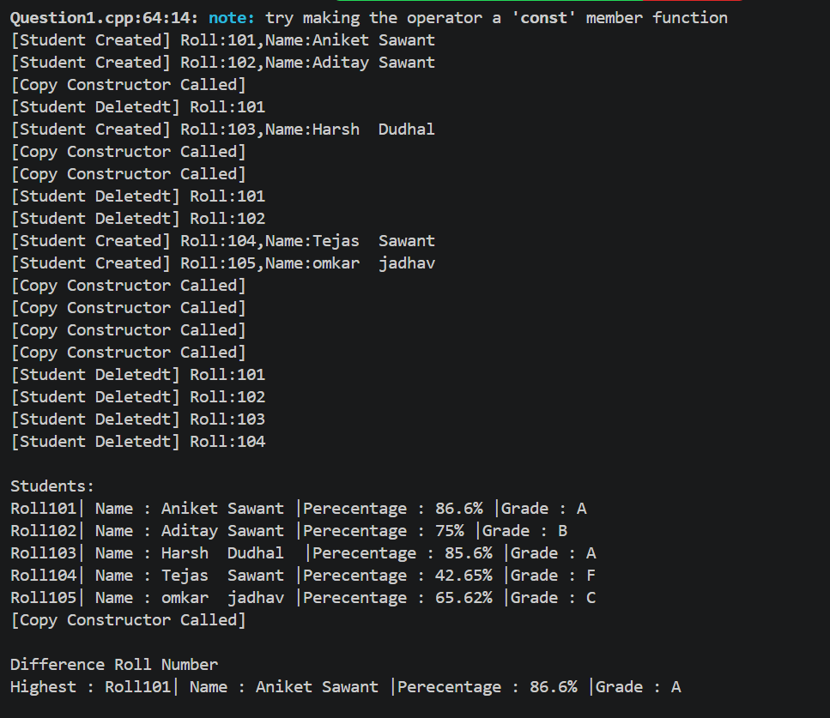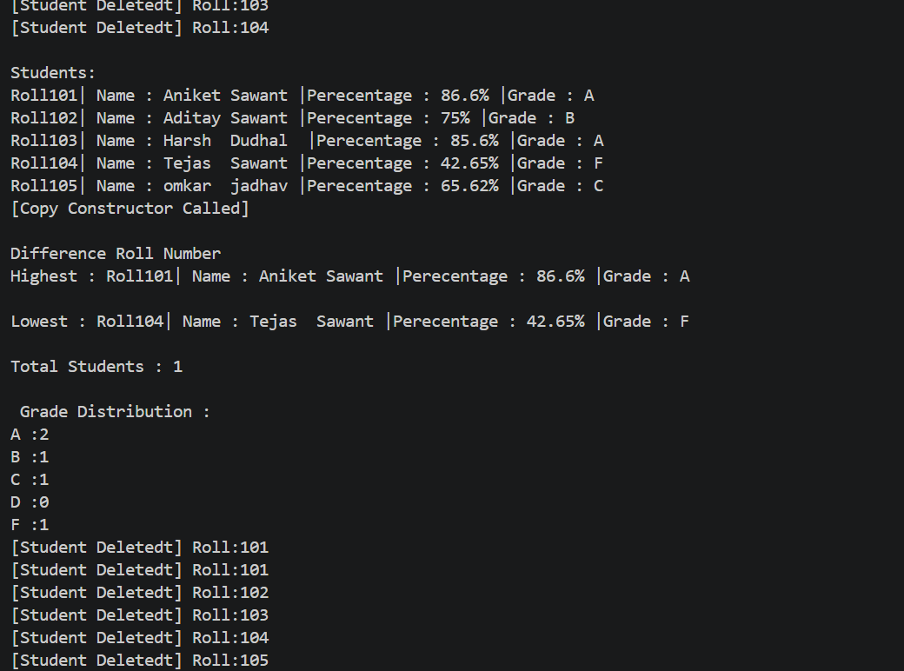

Question 2:
#include <iostream>
#include <string>
using namespace std;

class Employee{
private:
int empId;
string name;
double salary;
int performanceR;

public:
Employee(int id,const string& empName,double sal,int rating):empId(id),name(empName),salary(sal),performanceR(rating){
cout<<"Para construcctor\n";
}

double calculateBonus()const{
if(performanceR==5)
return salary*0.20;
else if(performanceR==4){
return salary*0.15;
}else if(performanceR==3)
return salary*0.10;
else if(performanceR==2){
return salary*0.05;
}else
return 0 ;
}
void displayDetails() const{
cout<<"ID : "<<empId
<<"|Name : "<<name
<<"|Salary : "<<salary
<<"|Rating: "<<performanceR
<<"|Bonus : "<<calculateBonus()
<<endl;

}

double getBonus()const{
return calculateBonus();
}
string getName()const{
return name;
}

};
int main(){
Employee emp[5]={
Employee(1,"Aniket Sawant",50000,5),
Employee(2,"Aditya chormule",35000,4),
Employee(3,"Om Sawant",25000,3),
Employee(4,"Sahil Sawant",15000,2),
Employee(5,"Harsh Sawant",15000,2),

};
for(int i=0;i<5;i++)
{
emp[i].displayDetails();
}

int maxIndex =0;

for(int i=1;i<5;i++)
{
if(emp[i].getBonus()>emp[maxIndex].getBonus())
{
maxIndex=i;
}
}
cout<<"\nEmployee with Maximun Bonus:"
<<emp[maxIndex].getName()
<<"with Bonus:"
<<emp[maxIndex].getBonus()
<<endl;
return 0 ;
}
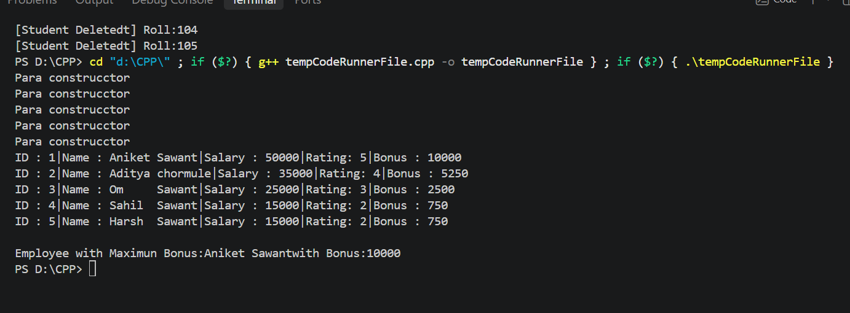

Question 3 :
#include <iostream>
using namespace std;

class Temperature{
private:
double celsius;

public:
Temperature(double c):celsius(c){

}

double toFahrenheit() const{
return (celsius*9/5)+32;
}
double toKelvin() const{
return celsius+273.15;
}

void displayAll() const{
cout<<"Temperature : "<<celsius<<"C = "
<<toFahrenheit()<<"F = "
<<toKelvin()<<"K"<<endl;
}
};

int main()
{
double celsius;
for(int i=0;i<3;i++)
{
cout<<"Enter temperature is Celcius :";
cin>>celsius;

if(celsius<-273.15)
{
cout<<"ERROR : Temperature below absolute zero(-273.15C)"<<endl;
}else{
Temperature t(celsius);
t.displayAll();
}

}
return 0;
}
